*Florida International University*

*School of Computing and Information Sciences*

Software Engineering Focus

Feature Document

User Story ID # 347

**Name:** Add Site Settings for Session Timeout

**Team Member(s):** Darilys Pereira

**Project:** Virtual Roll Call 4.0

**Product Owner(s)**: Jason Cohen

**Mentor(s)**: Juan Caraballo

**Instructor**: Masoud Sadjadi

**User Story Name:** Add Site Settings for Session Timeout

* Description: **As an** Administrator I **would like** to control the timeout period so that users are kicked out of the system if there are idle for such time **so that** it’s easy to customize based on police department needs and requirements.

Acceptance Criteria

* Add section to Site Settings to enter the timeout period in minutes.
* This section is only controlled by Administrators.
* Users that are idle for the number of minutes in that setting should be logged out of the system.

**Use Case**

* Name: Change Timeout
* Actor: Administrator
* Preconditions:

1. System is up and running
2. Administrator has successfully logged into the system.
3. Connection to the database has been established.

* Description:

1. Administrator clicks on the Site Settings side menu under the Administrator section of the application.
2. Administrator enters the time in minutes under the Session Timeout section of Site Settings.
3. Administrator clicks the Update button.

**Use Case Diagram**

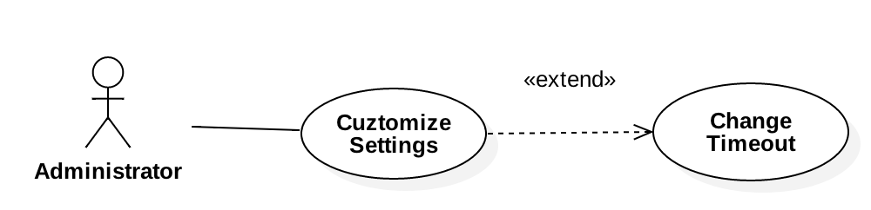

**Sequence Diagram**

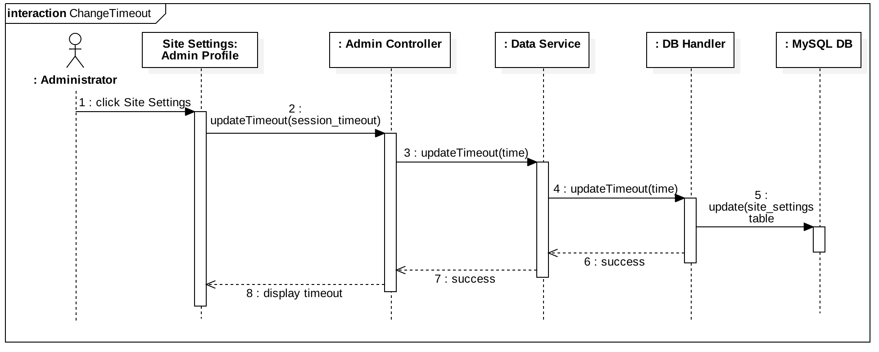

**Class Diagram**

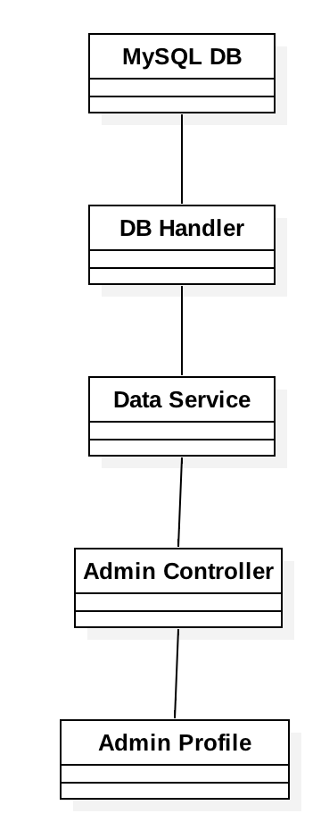

**Unit Test**

* Test case ID: User Story # 347 - Change Timeout
* Description/Summary of Test: Verify administrators can update the timeout period through site settings.
* Pre-condition:

1. User is logged in.
2. User is in Site Settings page.

* Expected Results: New values are updated in the database and Current Site Settings section is updated with new data.
* Actual Result: Success message is displayed in the UI advising user that the change was processed correctly. Data was saved in the database. Current Site Settings section reflects new timeout period entered.
* Status (Fail/Pass): Pass

**Integration Test**

System was tested by:

1. Updating the timeout period several times and verifying session timeout feature is performed based on value in this field.
2. Tried updating other fields of the Site Settings page and verified is being updated correctly in the DB.

**Visual User Guide**



